# Chatbot Design

%3CmxGraphModel%3E%3Croot%3E%3CmxCell%20id%3D%220%22%2F%3E%3CmxCell%20id%3D%221%22%20parent%3D%220%22%2F%3E%3CmxCell%20id%3D%222%22%20value%3D%22%26lt%3Bfont%20style%3D%26quot%3Bfont-size%3A%2018px%26quot%3B%26gt%3Bstart%26lt%3B%2Ffont%26gt%3B%22%20style%3D%22ellipse%3BwhiteSpace%3Dwrap%3Bhtml%3D1%3Baspect%3Dfixed%3B%22%20vertex%3D%221%22%20parent%3D%221%22%3E%3CmxGeometry%20x%3D%22110%22%20y%3D%22265%22%20width%3D%2280%22%20height%3D%2280%22%20as%3D%22geometry%22%2F%3E%3C%2FmxCell%3E%3C%2Froot%3E%3C%2FmxGraphModel%3E__----------------------------------------------------------------------------------------------%3D%221%22%3E%3CmxGeometry%20x%3D%22110%22%20y%3D%22265%22%20width%3D%2280%22%20height%3D%2280%22%20as%3D%22geometry%22%2F%3E%3C%2FmxCell%3E%3C%2Froot%3E%3C%2FmxGraphModel%3E__----------------------------------------------------------------------------------------------%3D%221%22%3E%3CmxGeometry%20x%3D%22110%22%20y%3D%22265%22%20width%3D%2280%22%20height%3D%2280%22%20as%3D%22geometry%22%2F%3E%3C%2FmxCell%3E%3C%2Froot%3E%3C%2FmxGraphModel%3E__----------------------------------------------------------------------------------------------%3D%221%22%3E%3CmxGeometry%20x%3D%22110%22%20y%3D%22265%22%20width%3D%2280%22%20height%3D%2280%22%20as%3D%22geometry%22%2F%3E%3C%2FmxCell%3E%3C%2Froot%3E%3C%2FmxGraphModel%3E__----------------------------------------------------------------------------------------------%3D%221%22%3E%3CmxGeometry%20x%3D%22110%22%20y%3D%22265%22%20width%3D%2280%22%20height%3D%2280%22%20as%3D%22geometry%22%2F%3E%3C%2FmxCell%3E%3C%2Froot%3E%3C%2FmxGraphModel%3E__------------------------------------------------------

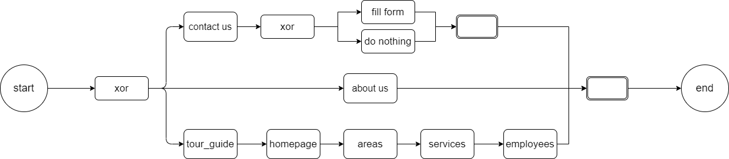

Our designed chatbot will contain an initial x-or with three different choices for three different use cases:

* A brief overview of our website and what we offer, which also redirects to the about us page. (About us decision)
* A long tour that shows all the most important pages of our website and gives a general overview of each section. (Tour guide decision)
* A contacts redirection for any other question that is not satisfied from the other two decisions. (Contact us decision)

The chat bot has been designed in this way so to support the first-time navigation of new visitors, and to tutor them on what our site offers while always giving them the possibility to contact us for any other questions.

A description of each state is the following:

-start: Shows on the chat the following text “Welcome to Hatgemini! Would you want to get a brief description about us, follow a tour of our website, or contact us for further questions? (Type “description”, “tour”, or “contacts” for your decision)”

This is just the initial welcome message.

-about us: Whilst redirecting to the “About us” page (with a custom payload) it shows on the chat a brief description of what our company offers and what he could buy.

-tour_guide: Writes on the chat “You have chosen the guide. We in Hatgemini proudly try to support our clients in a step-by-step process through professional counselling and off-the shelf products.” At this step we do not redirect. Every activity on this guide uses the “guide” callback which sends the site to correct pages at each activity.

-homepage: This activity writes on the chat “Welcome to the homepage. Here you will find some of the newest articles and services we provide. Keep an eye out for some of our famous employees too.” All the following activities, including this current one, redirect to their respective pages.

-areas: It writes “This is our areas page. Here you can find all the areas of expertise of our company such as Gaming and Entertainment.”

-services: This activity writes on the chat “Welcome to the services page of our website. Here you can find all the services and products we are working on.”

-employees: This activity writes: “The most interesting page of all, this is where you get to know all of our employees.”

-contact us: The activity writes on the chat “Would you like to contact us through a forum or through our hotline”. In the following two activities, after either choice, we redirect the user to the contacts page where it keeps both the form and the numbers of our hotline. The only difference between the two states is the message it is shown:

“Do not hesitate to (write/ask) us any question through the (form/hotline)”

-end: In the end state we only write a goodbye message: “Thank you for your patience.”.

A list of continue messages would be provided such as the following:

-"continue", "ok", "go", "yes", "sure".

At each message received that is not contained in the above list, we would remind the user to only write “ok” or “yes” although other messages might work.

In the x-or states, the continue messages would be different (as demonstrated in the examples above) and a correct message would be shown to remind the user.